Exercise 7: Packages

Scenario 1: Group all customer-related procedures and functions into a package.
o Question: Create a package CustomerManagement with procedures for adding a new customer, updating customer details, and a function to get customer balance.

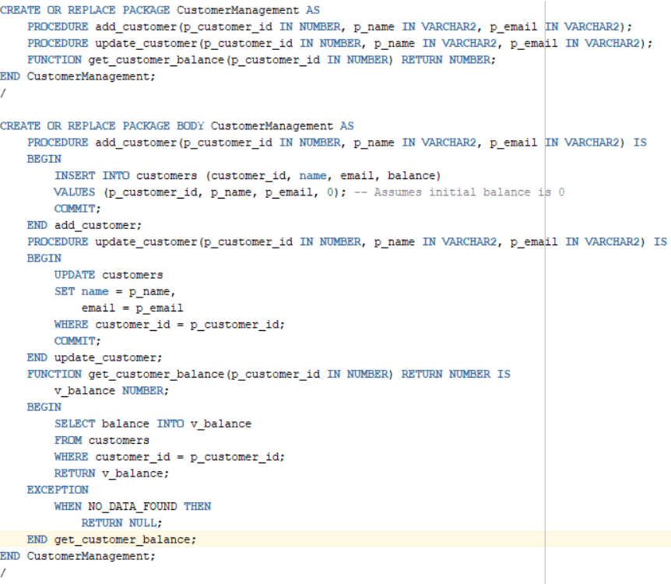
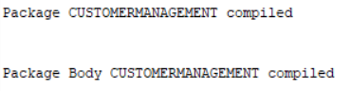

Scenario 2: Create a package to manage employee data.
o Question: Write a package EmployeeManagement with procedures to hire new employees, update employee details, and a function to calculate annual salary.
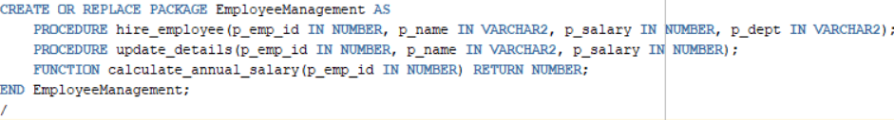
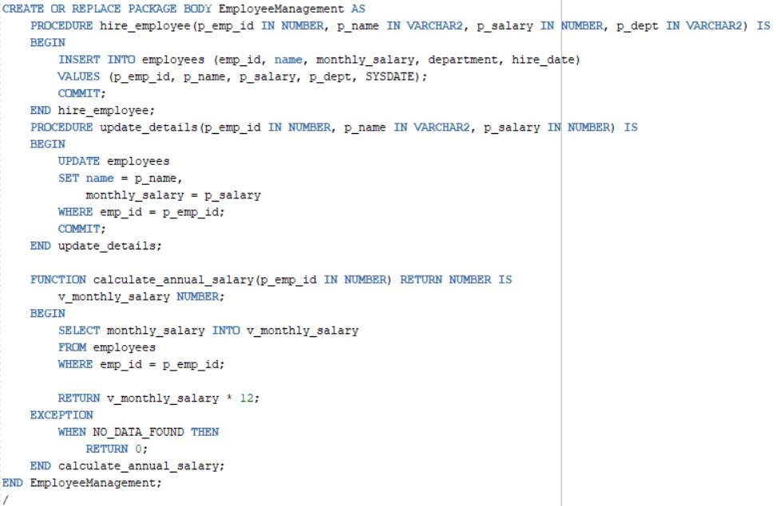

Scenario 3: Group all account-related operations into a package.
o Question: Create a package AccountOperations with procedures for opening a new account, closing an account, and a function to get the total balance of a customer across all accounts.
